✅ React Frontend Screenshots for CRUD operation
Prerequisite : Ensure Taskify Backend server is up and running at localhost at port 5000
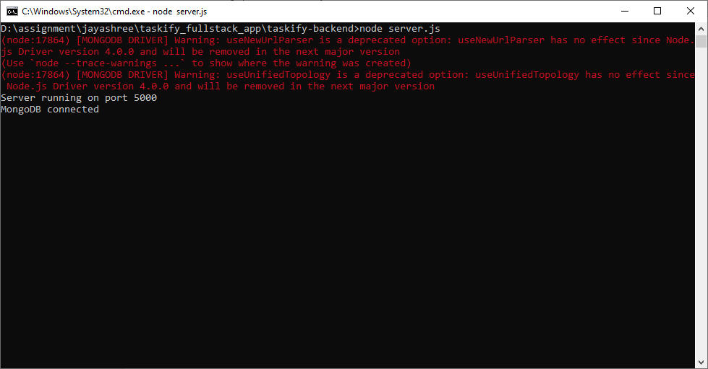
http://localhost:5000/tasks
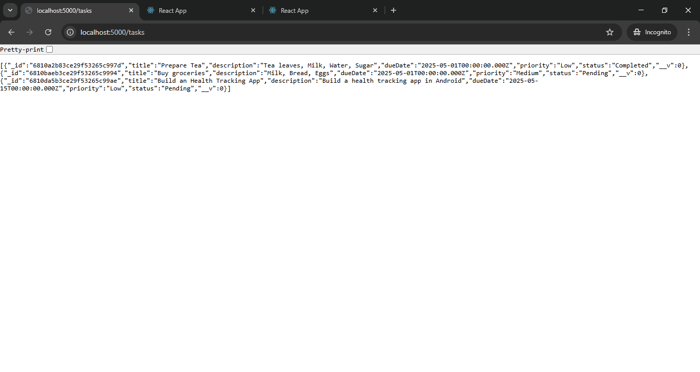

Assuming the React app is running at http://localhost:3000:

1. Create New Task
List of available tasks
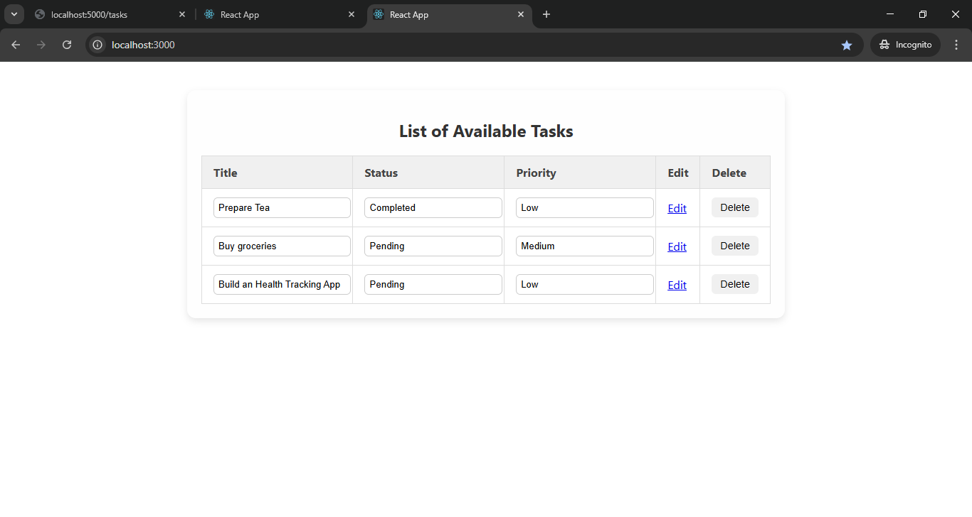
- URL:
http://localhost:3000/tasks/new
- Purpose: Opens the page with a form to create a new task.
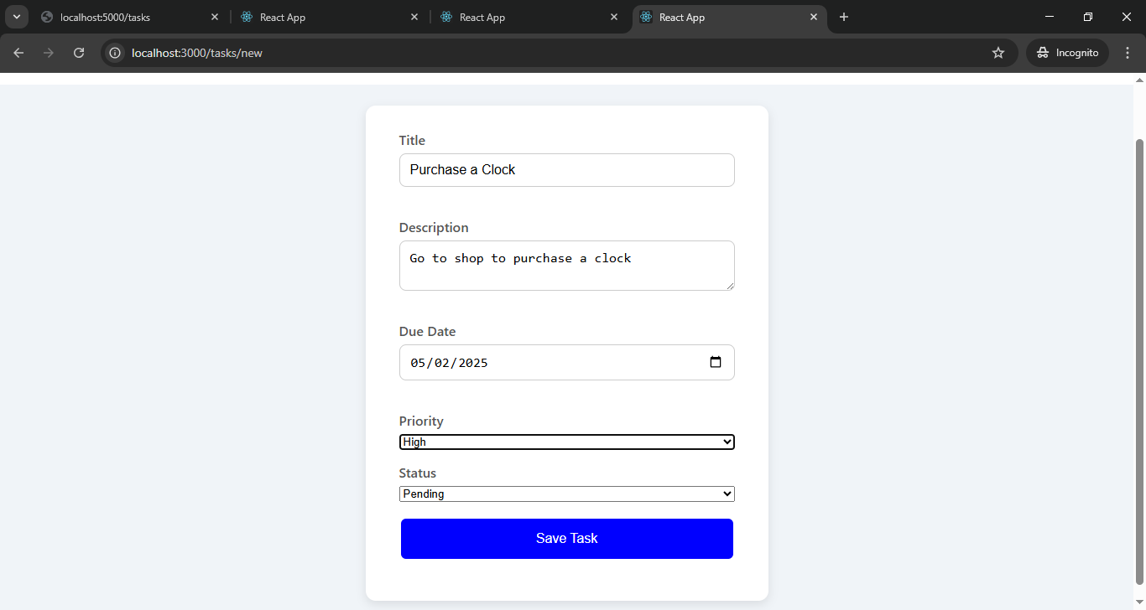
New task created/added
2. Fetch All Tasks
- URL: http://localhost:3000/
- Purpose: The homepage lists all tasks.

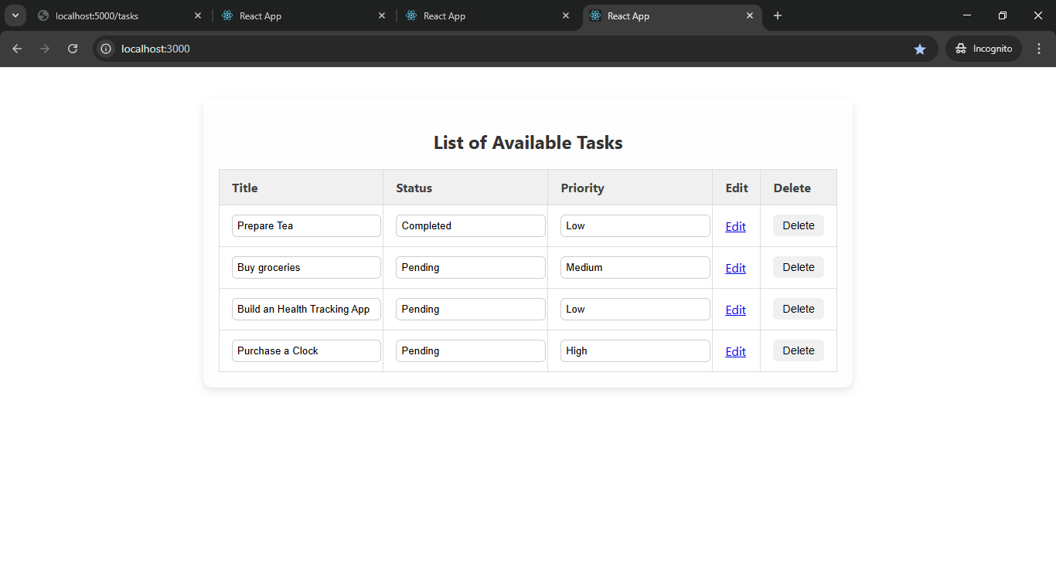
3. Fetch Task by ID / Edit Task/Update Task
- URL pattern: http://localhost:3000/tasks/{taskid}
Click on Edit Link to Edit task -> Edit task Form opens->Modify the form and Save
Before editing for task http://localhost:3000/tasks/6810baeb3ce29f53265c9994
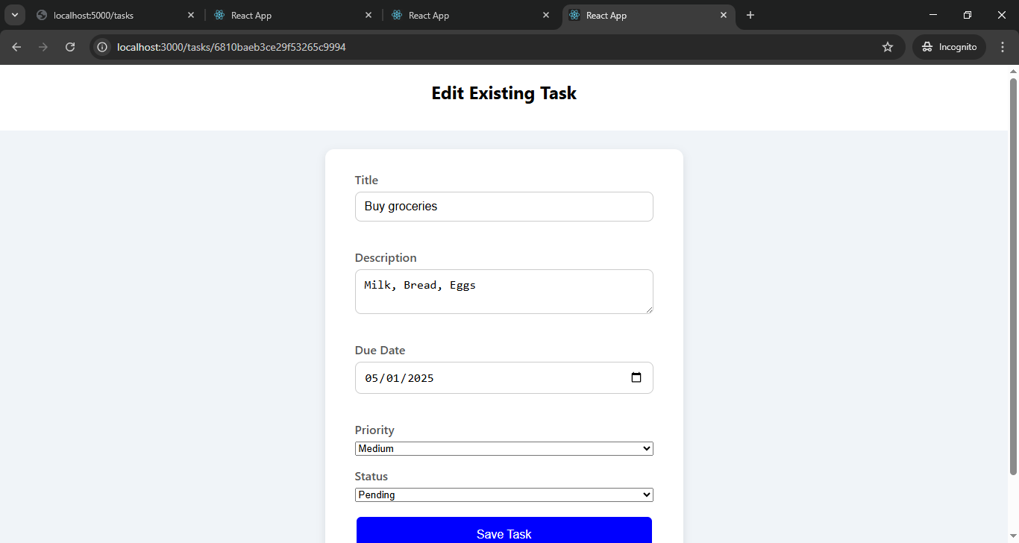
After update
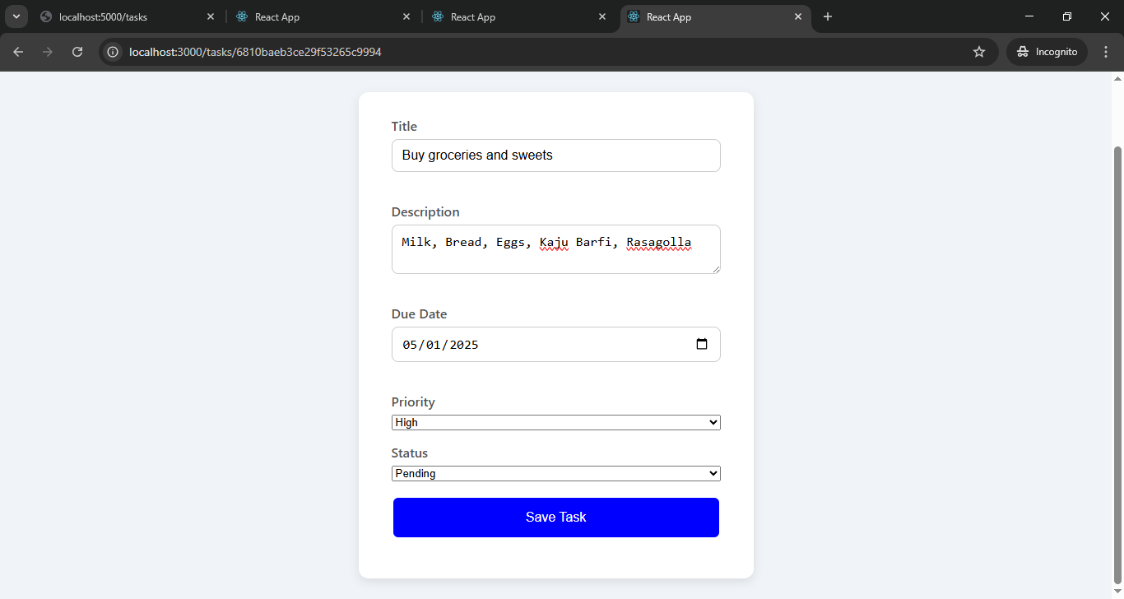
List of available task after update at http://localhost:3000/
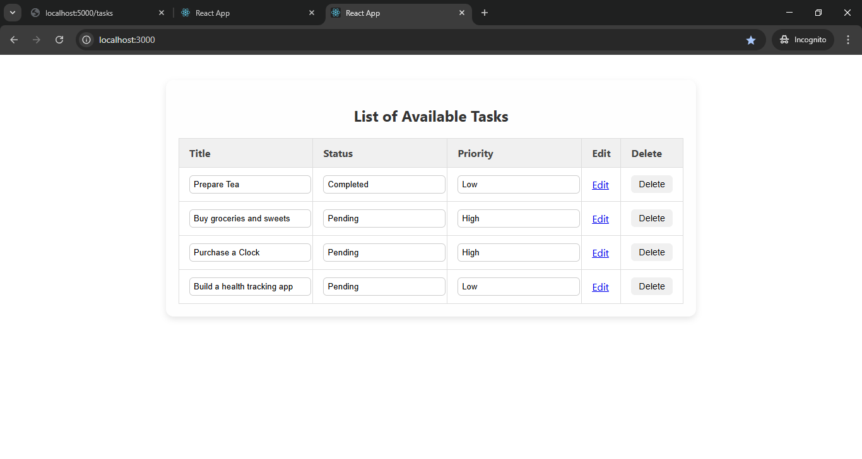
4. Delete Task
Let’s delete fourth entry “Build a health tracking app”.
Click on Delete Button against task which needs to be deleted.
List of available tasks after deletion. 